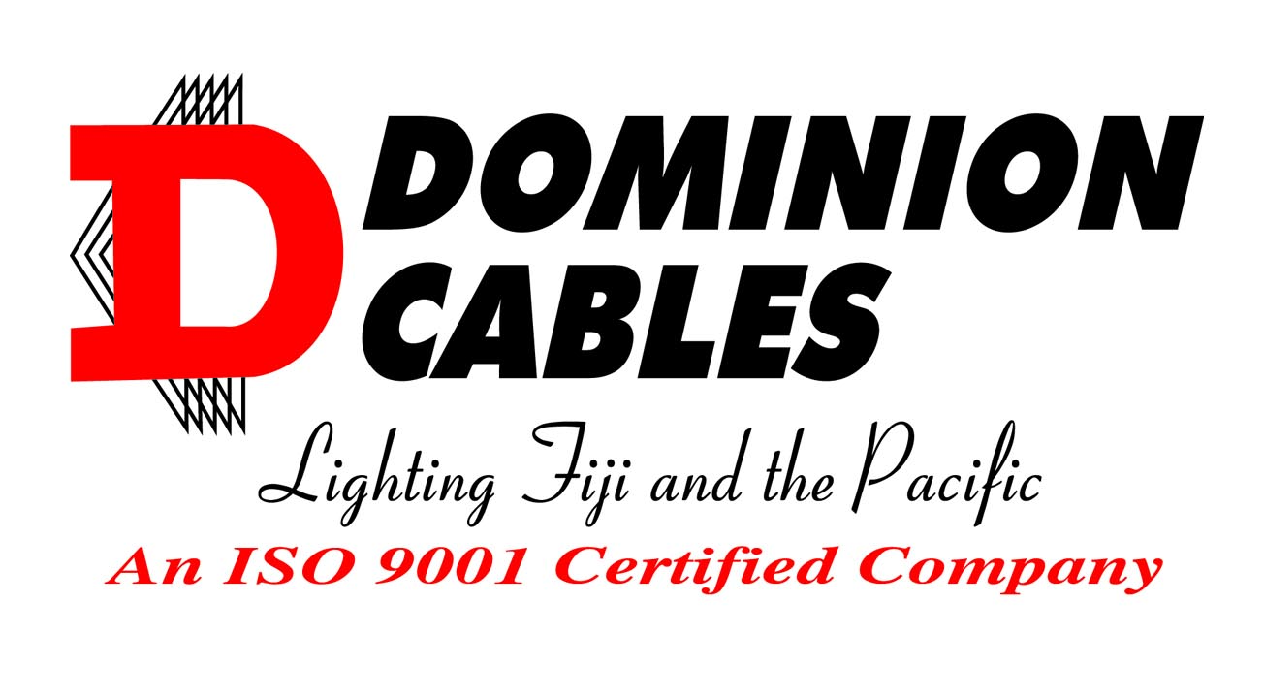

**FLAT TPS**

TWIN CORE COPPER

TWIN FLAT TPS 450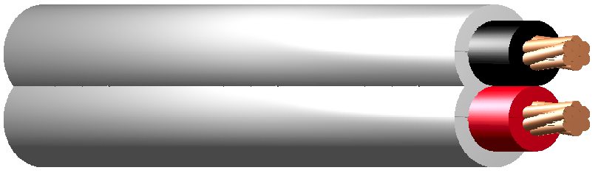

## APPLICATION

Easi-peel sheath for general wiring, unenclosed, in conduit, buried direct or in underground ducts for domestic, commercial and industrial installations where not subject to mechanical damage.

**STANDARD** AS/NZS 5000.2

**VOLTAGE** 450/750V

**CONDUCTOR** Copper 1 - 16mm2

**INSULATION** PVC, V-90

Red & Black or Red & White

**SHEATH** PVC, 3V-90

White

**MAX. OPERATING TEMP.** 90 **°**C

|  |  |  |  |  |  |  |
| --- | --- | --- | --- | --- | --- | --- |
| **Item**  **Number** | **Insulation**  **Colour** | **Conductor** | | **Overall Diameter** | **Approx.**  **Mass**  **kg/km** | **Minimum**  **Installed**  **Bending Radius**  **mm** |
| **mm2** | **(No./mm)** | **Nominal**  **mm** |
| DC209 R/B | Red+Black | 1 | 1/1.13 | 4.3 x 6.7 | 60 | 40 |
| DC209 R/W | Red+White | 1 | 1/1.13 | 4.3 x 6.7 | 60 | 40 |
| DC229 R/B | Red+Black | 1.5 | 7/0.50 | 4.7 x 7.4 | 80 | 50 |
| DC229 R/W | Red+White | 1.5 | 7/0.50 | 4.7 x 7.4 | 80 | 50 |
| DC249 R/B | Red+Black | 2.5 | 7/0.67 | 5.5 x 9.0 | 100 | 55 |
| DC249 R/W | Red+White | 2.5 | 7/0.67 | 5.5 x 9.0 | 100 | 55 |
| DC259 R/B | Red+Black | 4 | 7/0.85 | 6.5 x 10.6 | 140 | 65 |
| DC259 R/W | Red+White | 4 | 7/0.85 | 6.5 x 10.6 | 140 | 65 |
| DC269 R/B | Red+Black | 6 | 7/1.04 | 7.0 x 11.7 | 200 | 75 |
| DC269 R/W | Red+White | 6 | 7/1.04 | 7.0 x 11.7 | 200 | 75 |
| DC279 R/B | Red+Black | 10 | 7/1.35 | 8.5 x 14.4 | 400 | 90 |
| DC279 R/W | Red+White | 10 | 7/1.35 | 8.5 x 14.4 | 400 | 90 |
| DC289 R/B | Red+Black | 16 | 7/1.70 | 9.7 x 16.7 | 600 | 100 |

DOMINION CABLES – LIGHTING FIJI AND THE PACIFIC A13

|  |  |  |  |  |  |  |  |
| --- | --- | --- | --- | --- | --- | --- | --- |
| **CONDUCTOR** | **CURRENT RATING (a)** | | | **ELECTRICAL CHARACTERISTICS** | | | |
| **Nominal Area**  **mm2** | **Unenclosed In Air**    **A** | **Surrounded by thermal insulation**    **A** | **Buried In Ducts**    **A** | **Maximum**  **DC Resistance @20°C**  **Ω/km** | **Maximum AC Resistance @90°C**  **Ω/km** | **Equivalent Star Reactance**  **Ω/km** | **Single Phase Voltage Drop**  **@90°C**  **mV/Am** |
| 1 (1/1.13) | 14 | 7 | 17 | 21.2 | 27.0 | 0.119 | 54.1 |
| 1.5 (7/0.50) | 18 | 9 | 21 | 13.6 | 17.3 | 0.111 | 34.7 |
| 2.5 (7/0.67) | 26 | 13 | 30 | 7.41 | 9.45 | 0.102 | 18.9 |
| 2.5 (1/1.78) | 26 | 13 | 30 | 7.41 | 9.45 | 0.102 | 18.9 |
| 4 | 34 | 17 | 39 | 4.61 | 5.88 | 0.102 | 11.8 |
| 6 | 44 | 22 | 50 | 3.08 | 3.93 | 0.0967 | 7.85 |
| 10 | 60 | 30 | 66 | 1.83 | 2.33 | 0.0906 | 4.68 |
| 16 | 80 | 40 | 114 | 1.15 | 1.47 | 0.0861 | 2.95 |

(a) Based on 40**°**C ambient air temperature and where applicable, burial depth of 0.5m, soil temperature of 25**°**C and soil resistivity of 1.2**°**C.m/W.

The above information is from the following sources: AS/NZS 3008.1.1:2009 (tables 10, 30, 35, 42)

AS 1125:2001 (table 2.3)

For installation with thermal insulation refer to AS/NZS 3008 for de-rating factors.

Do not put in direct contact with polystyrene, polyurethane or similar thermal insulation materials.

***DOMINION WIRE & CABLES LTD.***

# QUALITY CABLE MANUFACTURES, DISTRIBUTORS AND EXPORTERS

**LOT 3, KINGS ROAD, YALALEVU, BA. P.O. BOX 1562, BA, FIJI.**

## PHONE: (679)6675244 FAX: (679)6670023,

## E-Mail: [sales@dominioncables.com](mailto:sales@dominioncables.com) Web: www.dominioncables.com

**Dominion Cables is a leader in the Cable Industry. The services of sales and technical staff are always available to assist with any enquiry.**

**The Dominion Cables policy is one of continual improvement. Details as published may be subject to change.**

This brochure is distributed with the understanding that the authors and editors are not responsible for the results of any action taken on the basis of information in this work, or any errors or omissions. Further, Dominion Cables is not engaged in rendering professional services. Dominion Cables expressly disclaims all and any liability to any person in respect of anything and of the consequences of anything done or omitted to be done by any such person in reliance whether whole or partial of the whole or any part of the contents of this publication. All rights reserve

DOMINION CABLES – LIGHTING FIJI AND THE PACIFIC A14 A10