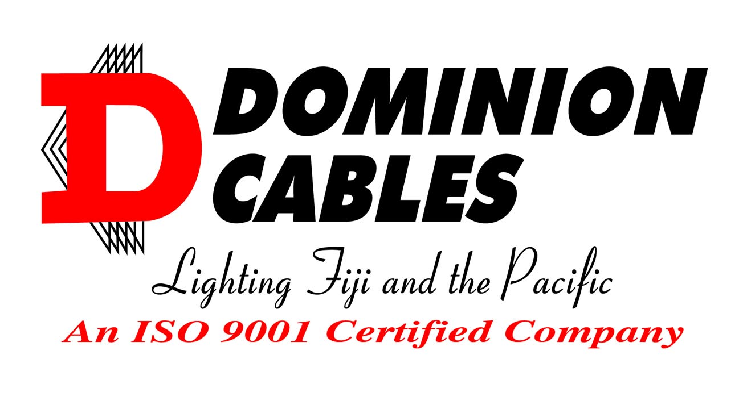

CIRCULAR PVC

2-50C + E

1.5 mm²

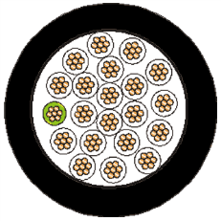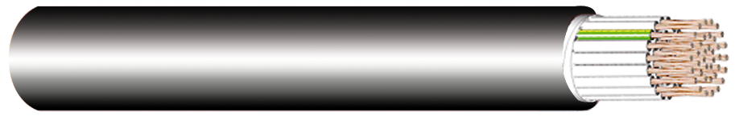

**STANDARD** AS/NZS 5000.3

**VOLTAGE** 600/1000V

**CONDUCTOR** Copper 1.5mm2

**INSULATION** PVC, V-90

White (with markings) & Green/Yellow

**SHEATH** PVC, 5V-90

Black

**MAX. OPERATING TEMP.** 90 °C

## APPLICATION

For control circuits unenclosed, enclosed in conduit, buried direct or in underground ducts for commercial, industrial, mining and electricity authority systems where not subject to mechanical damage.

Suitable for glanding.

|  |  |  |  |  |  |  |  |
| --- | --- | --- | --- | --- | --- | --- | --- |
| **Item**  **Number** | **Conductor** | | | **Overall Diameter** | | **Approx.**  **Mass**  **kg/km** | **Minimum**  **Installed**  **Bending**  **Radius**  **mm** |
| **Number**  **of**  **Cores** | **mm2** | **(No./mm)** | **Min**  **mm** | **Max**  **mm** |
| DC620 | 5 + E | 1.5 | 7/0.50 | 13.0 | 13.9 | 240 | 85 |
| DC720 | 6 + E | 1.5 | 7/0.50 | 13.0 | 13.9 | 280 | 85 |
| DC820 | 7 + E | 1.5 | 7/0.50 | 15.0 | 16.0 | 290 | 95 |
| DC1120 | 10 + E | 1.5 | 7/0.50 | 16.6 | 17.6 | 380 | 105 |
| DC1320 | 12 + E | 1.5 | 7/0.50 | 17.4 | 18.5 | 440 | 110 |
| DC1620 | 15 + E | 1.5 | 7/0.50 | 17.5 | 18.6 | 520 | 110 |
| DC2120 | 20 + E | 1.5 | 7/0.50 | 22.3 | 23.6 | 600 | 145 |
| DC2620 | 25 + E | 1.5 | 7/0.50 | 22.8 | 24.2 | 730 | 145 |
| DC3120 | 30 + E | 1.5 | 7/0.50 | 24.5 | 25.9 | 850 | 155 |
| DC4120 | 40 + E | 1.5 | 7/0.50 | 28.5 | 30.2 | 1090 | 180 |
| DC5120 | 50 + E | 1.5 | 7/0.50 | 30.0 | 31.7 | 1330 | 190 |

DOMINION CABLES – LIGHTING FIJI AND THE PACIFIC

|  |  |  |  |  |  |  |  |
| --- | --- | --- | --- | --- | --- | --- | --- |
| **CONDUCTOR** | **CURRENT RATING (a)** | | | **ELECTRICAL CHARACTERISTICS** | | | |
| **Number of Cores** | **Unenclosed In Air**    **A** | **Non-metallic**  **wiring enclosure in air**  20C+E_NONMETENCL  **A** | **Buried In Ducts**    **A** | **Maximum**  **DC Resistance @20°C**  **Ω/km** | **Maximum AC Resistance @90°C**  **Ω/km** | **Equivalent Star Reactance**  **Ω/km** | **3 Phase Voltage Drop**  **@90°C**  **mV/Am (b)** |
| 2 | 15 | 14 | 18 | 13.6 | 17.3 | 0.111 | 30.0 |
| 3 - 50 | 15 | 14 | 18 | 13.6 | 17.3 | 0.111 | 30.0 |

(a) Based on 40**°**C ambient air temperature and where applicable, burial depth of 0.5m, soil temperature of 25**°**C and soil resistivity of 1.2**°**C.m/W. Based on 2 to 4 cores fully loaded with the remainder of the cores <35% loaded.

(b) For single phase voltage drop, multiply by 1.155.

The above information is from the following sources: AS/NZS 3008.1.1:2009 (tables 13, 30, 35, 42)

AS 1125:2008 (table 2.3)

For installation with thermal insulation refer to AS/NZS 3008 for de-rating factors.

Do not put in direct contact with polystyrene, polyurethane or similar thermal insulation materials.

|  |  |  |  |  |  |  |
| --- | --- | --- | --- | --- | --- | --- |
| **ACTIVE / CONDUCTOR** | | | | **EARTH** | | |
| **Number of**  **Cores** | **Number & Diameter**  **of Wires**  **No/mm** | **Nominal Diameter**  **mm** | **Minimum Insulation**  **Thickness**  **mm** | **Nominal**  **Area.**  **mm2** | **Number & Diameter**  **of Wires**  **No/mm** | **Minimum Insulation**  **Thickness**  **mm** |
|  |  |  |  |  |  |  |
| 2 - 50 | 7/0.50 | 1.5 | 0.8 | 1.5 | 7/0.50 | 0.8 |

***DOMINION WIRE & CABLES LTD.***

# QUALITY CABLE MANUFACTURES, DISTRIBUTORS AND EXPORTERS

**LOT 3, KINGS ROAD, YALALEVU, BA. P.O. BOX 1562, BA, FIJI.**

## PHONE: (679)6675244 FAX: (679)6670023,

## E-Mail: [sales@dominioncables.com](mailto:sales@dominioncables.com) web: www.dominioncables.com

**Dominion Cables is a leader in the Cable Industry. The services of sales and technical staff are always available to assist with any enquiry.**

**The Dominion Cables policy is one of continual improvement. Details as published may be subject to change.**

This brochure is distributed with the understanding that the authors and editors are not responsible for the results of any action taken on the basis of information in this work, or any errors or omissions. Further, Dominion Cables is not engaged in rendering professional services. Dominion Cables expressly disclaims all and any liability to any person in respect of anything and of the consequences of anything done or omitted to be done by any such person in reliance whether whole or partial of the whole or any part of the contents of this publication. All rights reserve

DOMINION CABLES – LIGHTING FIJI AND THE PACIFIC